1. Unable to login Github enterprise

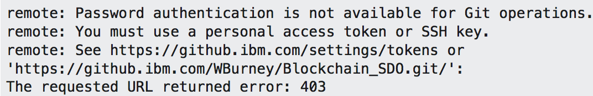

            Resolution:

            1) Applications > Keychain Access > select “login” (upper) and “password”(lower) > search “github” > select “Github - <https://github.ibm.com/> “

            2) Right click and copy password > enter Mac login password and click “Always allow” > paste github password in a note

            3) use “zrlzhang/<github password> to login in command